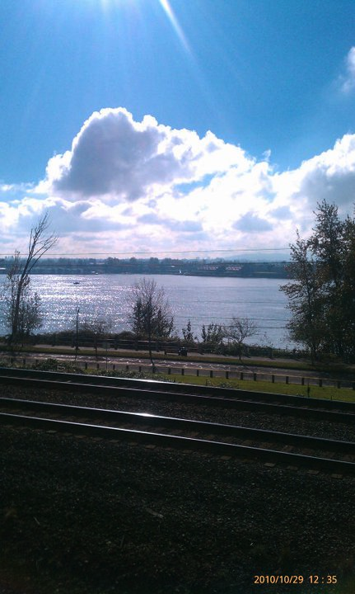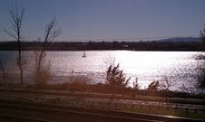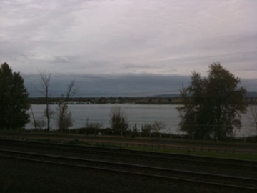

Botros:
Paul Kane recalls the bad weather and the unique state of the Columbia River being frozen over. Historically this rarely occurs and might be and interesting story to tell through Paul Kane’s view. He did not draw the river in the frozen state so maybe we can find other documented images of the river frozen over and use Paul Kane’s words,
“During the five months’ autumn and winter, it rains almost continuously, with very little frost or snow. The river, however, was frozen over for a short time during the winter I spent there, but it was remarked as the coldest season ever experienced; during the other seven months the weather is dry and sultry.”
Interaction: Ask the user to document the weather through taking a photo of the river from the land bridge.
Question to Mobile app user: “How is the weather today?

